**HORMISDALLEN SCHOOL - KYEBANDO**

**PRE- PLE SET 5 EXAMINATIONS, 2023**

**PRIMARY SEVEN SOCIAL STUDIES**

**Duration: 2 Hours 15 Minutes**

**NAME: ______________________________________________ STREAM: _________**

INDEX NO.

EMIS NO.

**SECTION A**

1. Which mineral is mined from Witwatersrand in South Africa?

____________________________________________________________________

1. Which forest led to the formation of Cape Ranges in South Africa?

____________________________________________________________________

1. State one measure taken by the government to reduce illiteracy.

____________________________________________________________________

1. Which system of arable farming provides double income to the farmer?

____________________________________________________________________

1. Name the landform found between East Africa mainland and the Indian Ocean.

____________________________________________________________________

1. Why are assemblies important in a school?

____________________________________________________________________

1. How did the Nandi and the Masaai make the exploration of East Africa difficult?

____________________________________________________________________

1. Draw a road sign for humps ahead.

|  |
| --- |
|  |

1. How are deciduous trees able to survive in dry conditions?

____________________________________________________________________

1. Name the flag which was replaced by the Union Jack.

____________________________________________________________________

1. How does terracing help to control soil erosion in hilly areas?

____________________________________________________________________

1. How does Food and Agricultural Organization(FAO) fight hunger among African countries?

____________________________________________________________________

1. In which one way are farmers able to grow crops in dry areas?

____________________________________________________________________

1. Which structure makes a Stevenson screen able to allow circulation of air?

____________________________________________________________________

1. Give any one reason why historical sites should be preserved.

____________________________________________________________________

1. Which element of a map is used to find the ground distance between two places?

___________________________________________________________________

1. State one problem faced by people in mountainous area.

____________________________________________________________________

1. Mention one way wattle trees promote the growth of leather tanning industries.

____________________________________________________________________

1. State any one way people benefit from taxes they pay to the government.

____________________________________________________________________

1. Write ATMIS in full.

____________________________________________________________________

1. Give one economic activity carried out in Savanna grassland area.

____________________________________________________________________

1. How did the relief of Ethiopia help her to resist colonial rule?

____________________________________________________________________

1. State one contribution made by Alexander Mackay in Uganda.

____________________________________________________________________

1. Give one problem faced by nomadic pastoralists in East Africa.

____________________________________________________________________

1. Mention one importance of having laws in a community.

____________________________________________________________________

1. 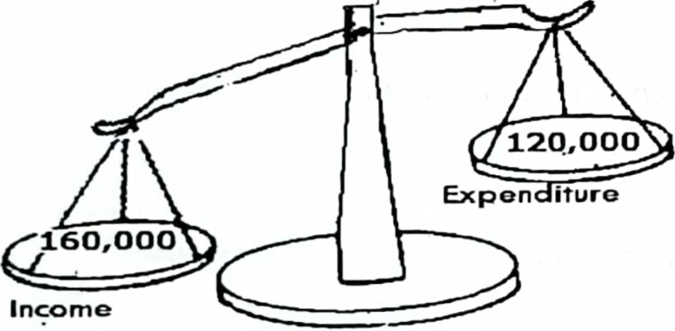Identify the type of budget illustrated below

____________________________________________________________________

1. State one proper method of managing wastes in the environment.

____________________________________________________________________

1. Give one advantage of living in urban area.

____________________________________________________________________

1. Compare the Tutsi and Boran in terms of ethnicity.

____________________________________________________________________

1. What social contribution was made by Sir Samuel Baker in Northern Uganda?

____________________________________________________________________

1. Write UBOS in full.

____________________________________________________________________

1. Give one way how parents mistreat their children at home.

____________________________________________________________________

1. Which organization united East African countries before 1977?

____________________________________________________________________

1. How do people of Uganda benefit from the coming of investors?

____________________________________________________________________

1. What is the population density of an area with 400,000people if its area is 800 square kilometers?

**For each of the questions 36 to 40, answer EITHER Christianity OR Islam but not both.**

1. **Either:** a) How is lent period important to Christians?

____________________________________________________________________

**OR:** a) How is Ramadhan important in Islam?

____________________________________________________________________

1. **Either:** a) What name is given to the last meal Jesus had with His apostles?

____________________________________________________________________

**OR:** a) What name is given to the early morning meal for Muslims in Ramadhan?

____________________________________________________________________

1. **Either:** a) Give one way you can care for God’s creation.

____________________________________________________________________

**OR:** a) Identify one way you can care for God’s creation.

____________________________________________________________________

1. **Either:** a) State one value of baptism to Christians.

____________________________________________________________________

**OR:** a) State one value of circumcision to Muslims.

____________________________________________________________________

1. **Either:** a) What is authority?

____________________________________________________________________

**OR:** a) What is authority?

____________________________________________________________________

**SECTION B(6oMARKS)**

1. a) What is meant by the term mining?

______________________________________________________________________________________________________________________________________

b) Identify one method of mining copper used in Africa. ___________________________________________________________________c) State any two importance of the mining industry to the people of Uganda.

i)__________________________________________________________________

ii)__________________________________________________________________

1. a) Give two reasons why Uganda trades with her neighbors.

i)__________________________________________________________________

ii)__________________________________________________________________

b) How is Port Mombasa important to Uganda?

___________________________________________________________________

c) Give one problem faced by Uganda due to her location.

__________________________________________________________________

1. a) In which Stone Age period did early man discover farming?

___________________________________________________________________

b) Give any two reasons why early man liked sitting near water bodies.

i)__________________________________________________________________

ii)__________________________________________________________________

c) State one other source of history besides archaeology.

___________________________________________________________________

1. Study the map below and answer the questions that follow.

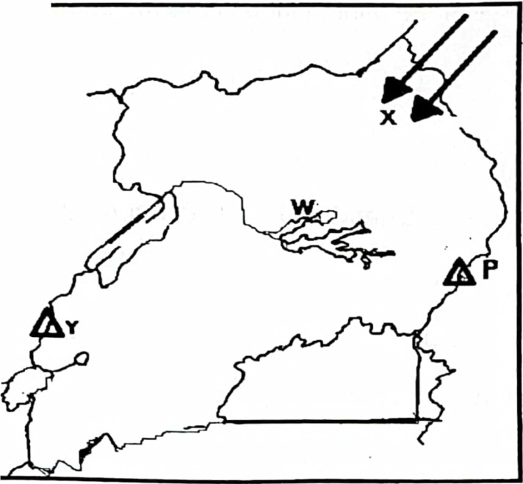

1. Which tribal group entered Uganda through route X?

________________________________________________________________

1. Name the lake marked W.

________________________________________________________________

1. Identify the direction of mountain marked Y from P.

________________________________________________________________

1. Why is the pick of mountain marked X snowcapped throughout the year?

________________________________________________________________

1. a) Give the meaning of the term government.

______________________________________________________________________________________________________________________________________

b) Name two organs of a democratic government.

i)__________________________________________________________________

ii)__________________________________________________________________

c) State the organ of government which punishes law breakers.

___________________________________________________________________

1. a) How does good transport promote trade in a country?

________________________________________________________________

b) Give any two advantages of road transport.

i)_______________________________________________________________

ii)_______________________________________________________________

c) Mention any one role played by the Uganda National Roads Authority

________________________________________________________________

1. a) Which official on the L.C.I committee is responsible for children’s rights?

___________________________________________________________________

b) Write any two of the children’s rights.

i)__________________________________________________________________

ii)__________________________________________________________________

c) Give any one way children are responsible for the abuse of their rights.

_________________________________________________________________

1. a) Why did Africans fight for their independence?

___________________________________________________________________

b) Name the nationalist who led Uganda to independence.

________________________________________________________________

c) Give any two ways in which Ugandans demanded for their independence.

i)__________________________________________________________________

ii)__________________________________________________________________

1. a) What is natural vegetation?

___________________________________________________________________

b) State any two importance of vegetation to wild animals.

i)__________________________________________________________________

ii)__________________________________________________________________

c) Mention the vegetation zone where most game parks are found.

___________________________________________________________________

1. Match the cash crops in list A with their uses in list b.

**List A (Crops) List B (uses)**

Cotton used to make sugar.

sugarcane used to make threads.

Oil palm trees used to make insecticides

pyrethrum used to make soap.

1. Cotton_______________________________________________________
2. Sugarcanes______________________________________________________
3. Oil palm trees_____________________________________________________
4. Pyrethrum_______________________________________________________

**For each of the questions 51 to 55, answer EITHER Christianity OR Islam but not both in a number. No marks will be awarded to a candidate who attempts both alternatives in the same number.**

1. **Either:** a) What event took place on Pentecost day?

___________________________________________________________________

b) In which two ways was the Holy Spirit important to the apostles?

i)__________________________________________________________________

ii)__________________________________________________________________

c) State any one symbol of the Holy Spirit.

___________________________________________________________________

**OR:** a) Differentiate between Iman and Imam.

___________________________________________________________________

___________________________________________________________________

b) Mention any two pillars of Islam.

i)__________________________________________________________________

ii)__________________________________________________________________

c) What role is played by the Muezzin in Islam?

___________________________________________________________________

1. **Either:** a) Why did Jesus call apostles?

___________________________________________________________________

b) Write brief notes about the following apostles of Jesus.

i) Simon Peter

__________________________________________________________________

ii) Judas Iscariot __________________________________________________________________

iii) Matthew

___________________________________________________________________

**OR:** a) Give the meaning of the term caliphs.

___________________________________________________________________

b) Mention any two caliphs of Prophet Muhammad.

i)__________________________________________________________________

ii)__________________________________________________________________

c) Why did Prophet Muhammad choose caliphs?

___________________________________________________________________

1. **Either:** a) Who taught the apostles how to pray?

___________________________________________________________________

b) Mention two requests Christians make in the Lord’s Prayer.

i)__________________________________________________________________

ii)__________________________________________________________________

c) Give one other way of communicating to God besides prayer.

___________________________________________________________________

**OR:** a) On which day do Muslims go for Juma prayers?

___________________________________________________________________

b) Why do Muslims attend Juma prayers?

___________________________________________________________________

c) State any two conditions that may spoil Salat.

i)__________________________________________________________________

ii)__________________________________________________________________

1. **Either:** a) State any two of the Ten Commandments important to Christians.

i)__________________________________________________________________

ii)__________________________________________________________________

b) In which way are God’s Commandments important to Christians?

___________________________________________________________________

c) Give one reason why Christians read the Bible.

__________________________________________________________________

**OR:** a) Mention any two holy books in Islam apart from the Quran.

i)__________________________________________________________________

ii)__________________________________________________________________

b) Give two reasons why Muslims read the Quran.

i)__________________________________________________________________

ii)__________________________________________________________________

1. **FOR BOTH:**

a) Give two reasons why people in your community work today.

i)__________________________________________________________________

ii)__________________________________________________________________

b) Mention two examples of work done by people in your community.

i)__________________________________________________________________

ii)__________________________________________________________________

**END**